How to run a search in the table.
First step:
open the table by clicking the arrow
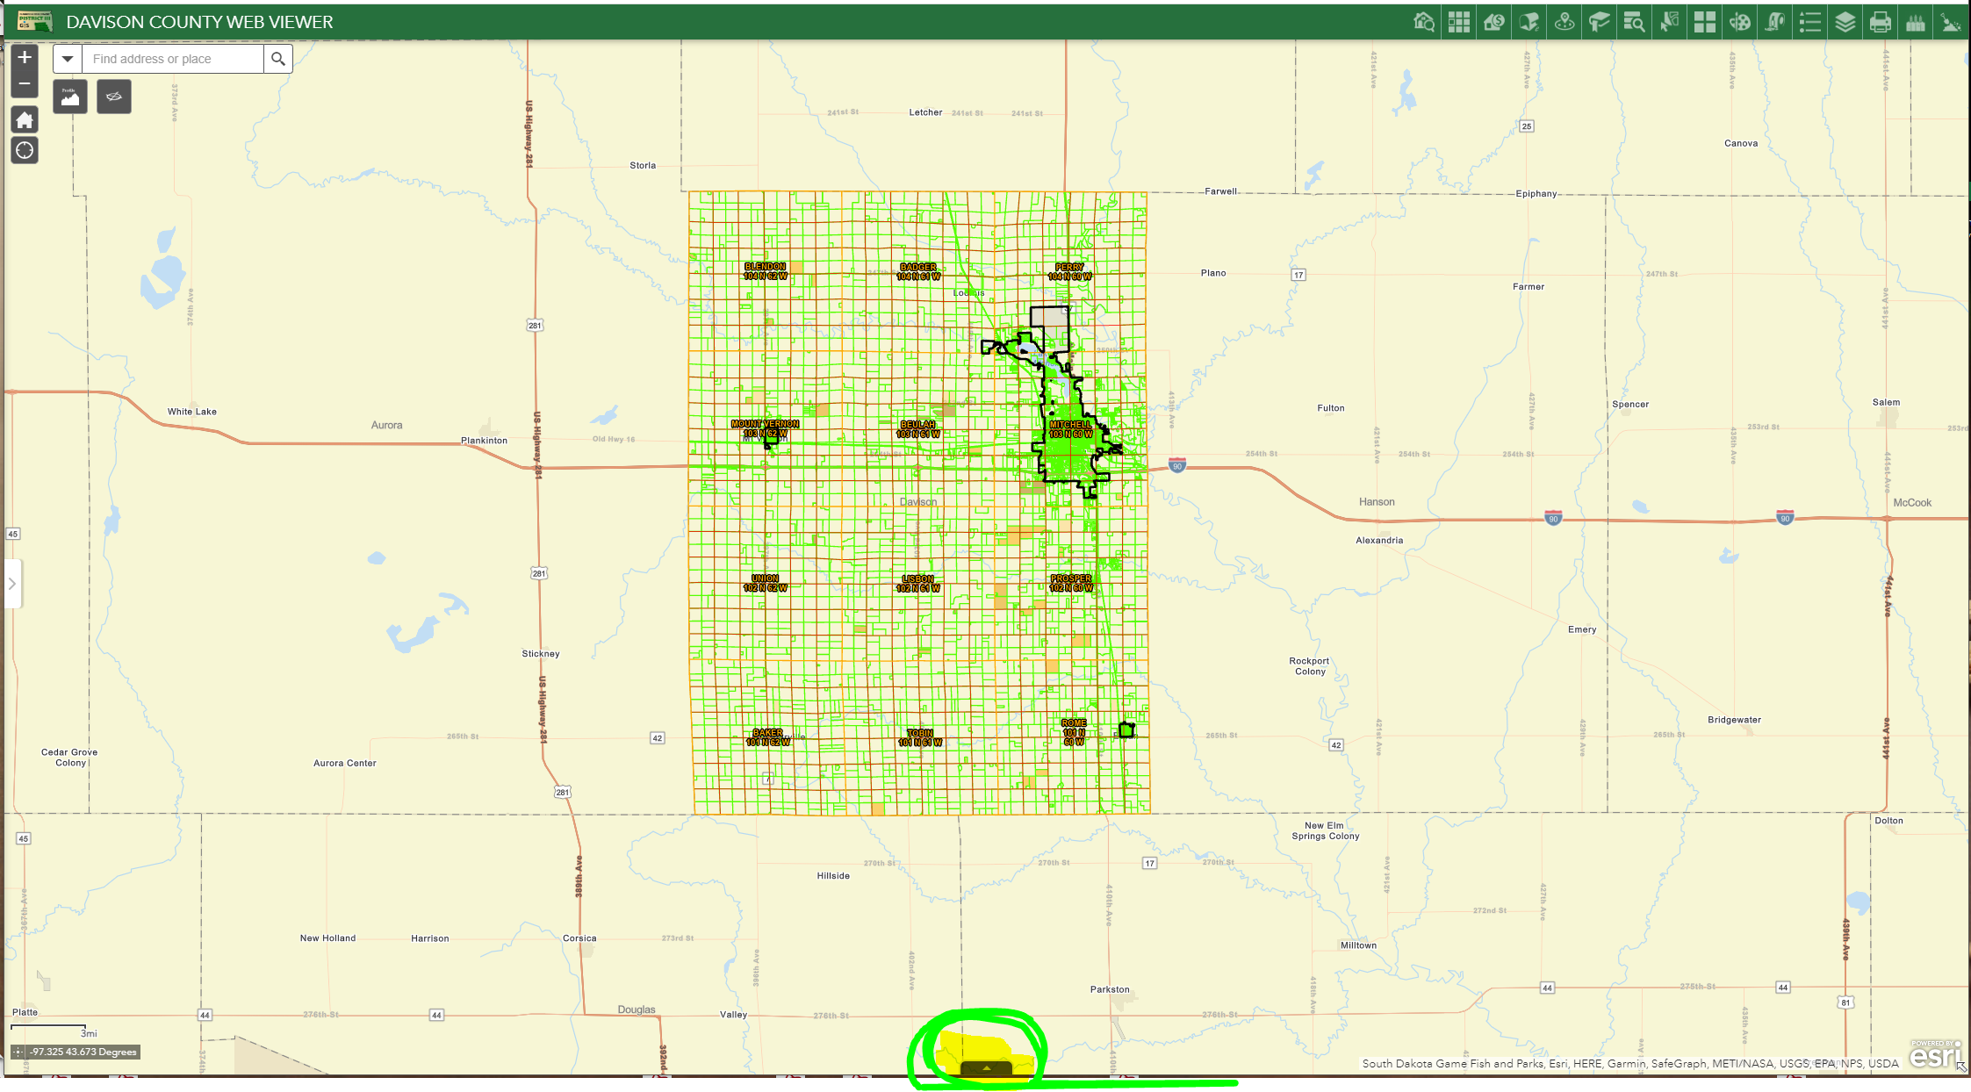
Second step:
By default the data will only show what is in the map extent. If you want the entire database, click off the “filter by map extent” button.
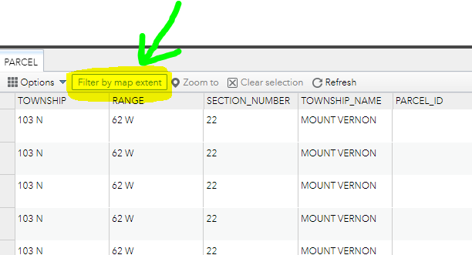

Step 3:
Click OPTIONS, then click FILTER , then click “add expression” to create a customized search
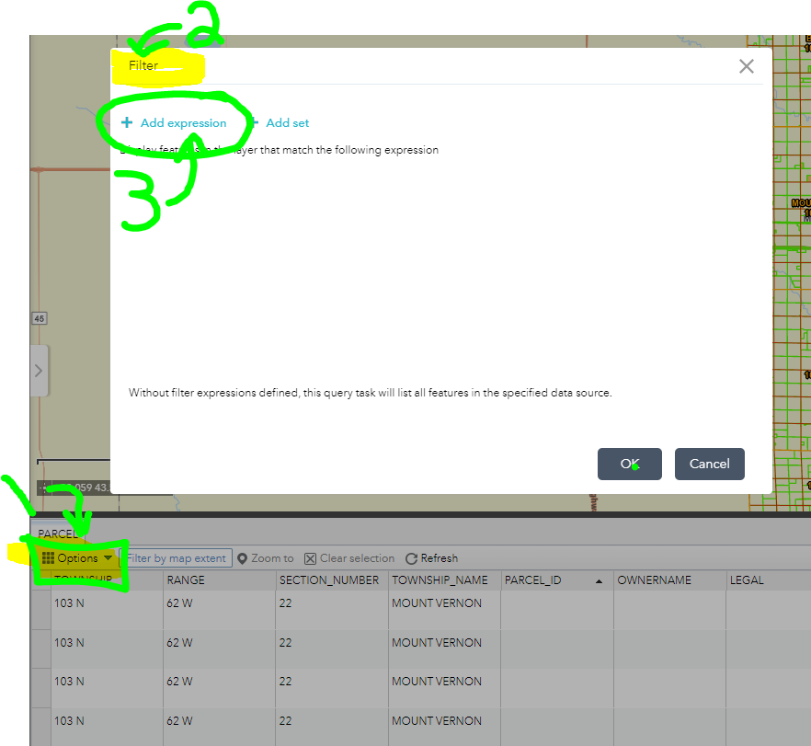
Step 4:
In the drop down fields, click the field you want to search. OWNER NAME then you will click the middle expression (is, is no, contains for example), then type what you are searching for.
Example:
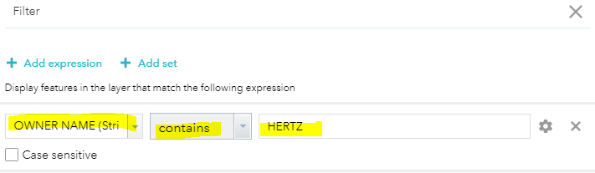

****AFTER YOU RUN A CUSTOMIZED SEARCH, YOU MUST DELETE THE SEARCH IN ORDER TO SEE OTHER DATA****

