HR NOtes
  - Unofficial publication September 23 Edition 2022/Issue 15

Welcome new employees
Hot Topic Question: explain to me again how the retirement works?
We are part of the SD Retirement system, and as such, all FT employees are too. It is only optional for elected positions. For class B members (public safety) 8% is deducted from your check and for class A (all others) 6 % is withheld. The county then matches that amount and deposits it in your SDRS account. Members become vested and entitled to lifetime retirement benefits after 3 years of service. If terminating before retirement, options are to leave it in the account for up to 10 years earning interest or get a refund.

Members who joined before 7/1/17 are Foundational and those after that time are Generational. Those divisions have a slightly different structure. Normal retirement age for Foundation members is 65 with early retirement available at age 55. Generational is 67 and 57. Public safety is 10 years earlier for each. Benefits are based on the final average compensation of the highest 20 consecutive quarters of the last 40.

If something happens to you, family benefits, surviving spouse, and disability are available. Special rules apply to reemployment. Check with HR if you plan to retire soon.
www.sdrs.sd.gov
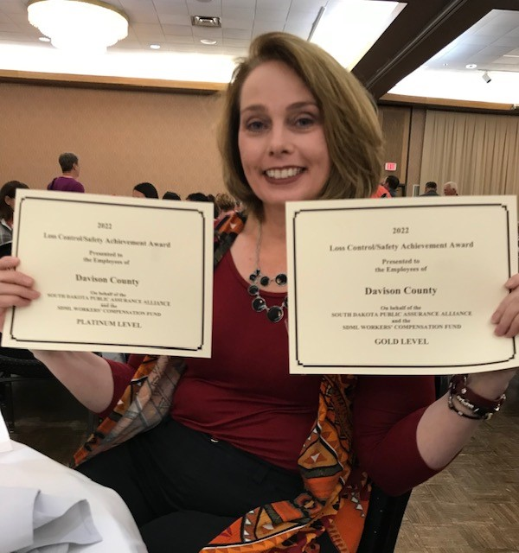
Lanning swearing in ceremony
Welcome to Kristi Juracek, FT Admin Assistant in the WIC office and welcome back to Cristal Villalvazo as a FT Corrections Officer. So long to Brett, Alex, Haley, and Sabrina-we wish you all the best.

Employee resource guide
Another change in our guide is that in order to provide a fair distribution of funeral leave, employees can still use 3 days for bereavment, but days are limited to 8 hours each.
The state just increased mileage rates, and as we follow those SDCLs, personal mileage will be reimbursed at $.51/mile if a county vehicle is not avaialable, and at $.28/mile if one is available and you choose to drive your own vehicle. This should help a little more with the high gas prices.
I received a different kind of training opportunity this week, which may be helpful for some. Taming Worrying Thoughts-check it out at
https://share.vidyard.com/watch/M9pUcSrU2NUv9bogb8G1ZX?

survey
Thank you for the great participation in our employee engagement survey. Results are coming out, but some highlights to note:
Highest motivators: Doing your best/a job well done and serving the people of Davison County
90% of employees would recommend employment here to others
92% would definitely or probably see themselves working for Davison County in two years
Congratulations to our employees for achieving both Gold and Platinum designations for risk management. Great job!
CONGRATS!
Upcoming birthdays: Karen F, Kyelle, Clayton, Karen W, Tyler D, Tyler B, Haley, Angela S, Katie, and Nathan.
Anniversaries: Angela S (4), Kim (9), Tonya M (11), Rusty (29), Carol (23) and Karen W (1).
Humpty Dumpty had a good summer, but he had a great “fall.”

